2520090081 – SAI RAM PRAGNEY MURIKIPUDI
PRACTICAL – 5
PROGRAM 1

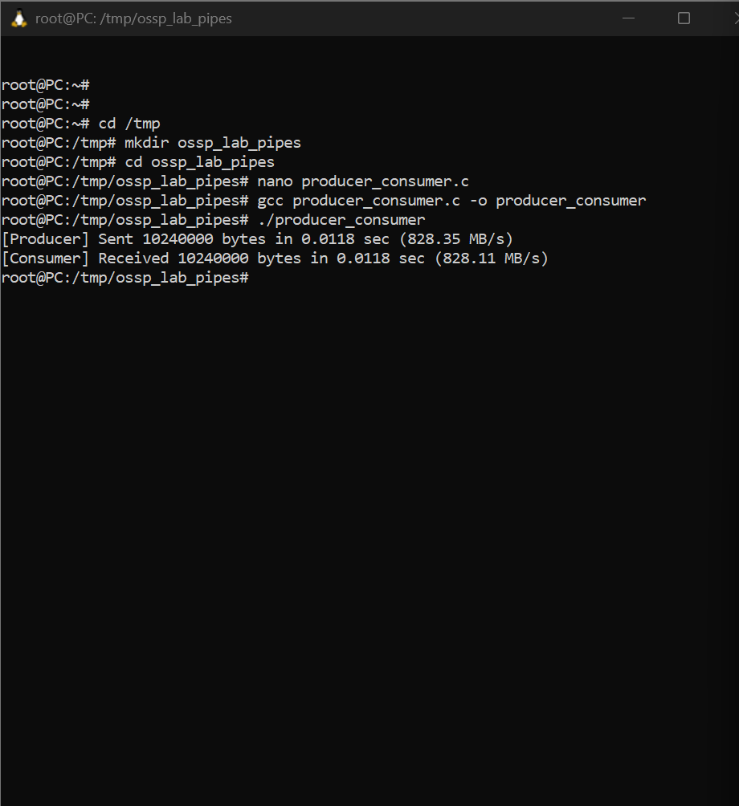
PROGRAM 2
